

MINI PROJECT-II REPORT

On



**Submitted by :-**

**Aniket Jain(201500091)**

**Ayush Kumar(201500180)**

**Prakhar Srivastava(201500493)**

**Devansh Kumar Sharma(201500214)**

Department of Computer Engineering & Applications

**Institute of Engineering & Technology**

**GLA University Mathura- 281406, INDIA**

**2022-2023**

##### Department of computer Engineering and Applications GLA University, Mathura

**17 km. Stone NH#2, Mathura-Delhi Road, P.O. – Chaumuha, Mathura – 281406**

**Declaration**

We hereby declare that the work which is being presented in the Mini Project “**File Sharing Website”,** in partial fulfillment of the requirements for Mini Project-II viva voce, is an authentic record of our own work carried by the team members under the supervision of our mentor Mr. Mandeep Singh

Group Members:

Aniket Jain(201500091)

Ayush Kumar(201500180)

Prakhar Srivastava(201500493)

Devansh Kumar Sharma(201500214)

Course: B.Tech (Computer Science and Engineering) Year: 3rd

Semester: 6th

Supervised By:

Mr. Mandeep Singh, Technical Trainer

GLA University, Department of Computer Engineering And Application

##### Department of computer Engineering and Applications GLA University, Mathura

**17 km. Stone NH#2, Mathura-Delhi Road, P.O. – Chaumuha, Mathura – 281406**

**CERTIFICATE**

This is to certify that the above statements made by the candidates are correct to the best of my/our knowledge and belief.

##### SUPERVISOR

##### Mr. Mandeep Singh

##### Technical Trainer

##### Department of Computer Engineering And Application , GLA University

# About the Project

File Transfer Web Application is used to upload any type of files like pdf, mp3, word, video, etc.) into a database table and can download any type of files from the database. The web application is developed in 3 tier architecture involving user interface, controller and database. The user interface will be a web page hosted on a server. The web page consists of both static and dynamic content. All the data required for the application is stored in database tables. Controller accesses the data from the database and provides it to the user through user interface (web page).

# Motivation

The purpose of this system will manage an file sharing. The User can upload its files or download the one already in the folder already uploaded by the itself.  When the User uploads a file in folder, the Receiver will receive an email alerting him of the new file and with a link to download it without logging in the File Sharing System.

# Acknowledgement

We thank the almighty for giving us the courage and perseverance in completing the project. This project itself is an acknowledgement for all those people who have given us their heartfelt co-operation in making this project a grand success. We extend our sincere thanks to Mr. Mandeep Singh, Technical Trainer at “GLA University, Mathura” for providing his valuable guidance at every stage of this project work. We are profoundly grateful towards the unmatched services rendered by him. And last but not least, we would like to express our deep sense of gratitude and earnest thanks giving to our dear parents for their moral support and heartfelt cooperation in doing the main project.

Aniket Jain(201500091)

Ayush Kumar(201500180)

Prakhar Srivastava(201500493)

Devansh Kumar Sharma(201500214)

## FILE SHARING WEBSITE

### Abstract

The File Transfer web application contains four web pages like Home page, Upload page, download Page and About Us page. On every page there are four buttons named Home, Upload, download and AboutUs, and the user can click on any of the button to go to that particular page. The Home page and AboutUs page contains details about the project. In the Upload page, the user can upload any type of files into a database table by selecting any file from the computer using ‘choose a file’ button and once the user click on the upload button the file will be uploaded to a database table. The Download page contains all the files that are in the database table. When the user clicks on a particular file that is displayed on a Download page the file will be downloaded into the computer. In this way the user can upload and download files using File Transfer Web Application.

# Contents

**Acknowledgment** 06

**Abstract** 07

1. **Introduction:**

Introduction to HTML, CSS, JAVASCRIPT, 09-10

Pre-requisites 10

1. Technologies Used:

Node.js………………………………………..11

VS code 13

1. List of Figures. 14-18
2. Software Testing 19-22
3. References 23
4. Conclusion 24
5. Bibliography…………………………………………..25

# Chapter 1

## Introduction HTML-

HTML stands for **H**yper**t**ext **M**arkup **L**anguage, and it is the most widely used language to write Web Pages.

**Hypertext** refers to the way in which Web pages (HTML documents) are linked together. Thus, the link available on a webpage is called Hypertext.

As its name suggests, HTML is a **Markup Language** which means you use HTML to simply "mark-up" a text document with tags that tell a Web browser how to structure it to display.

Originally, HTML was developed with the intent of defining the structure of documents like headings, paragraphs, lists, and so forth to facilitate the sharing of scientific information between researchers.

Now, HTML is being widely used to format web pages with the help of different tags available in HTML language.

HTML is the *language* for publishing web pages on the WWW (World-Wide Web).

HTML is a *Document Description Language* (aka *Document Markup Language*). HTML is NOT a programming language like C/C++/C#/Java, which is used to implement programming algorithm.

You need a web browser to view the HTML pages. The web browsers do not display the HTML tags, but uses the tags to interpret the content of the web pages.

An HTML document is a text document, and it is human-readable.

HTML was originally developed by **Tim Berners-Lee in 1990.** He is also known as the father of the web. In 1996, the World Wide Web Consortium (W3C) became the authority to maintain the HTML specifications. HTML also became an international standard (ISO) in 2000.

## CSS-

CSS is short for **C**ascading **S**tyle **S**heets, and is the preferred way for setting the look and feel of a website. Cascading Style Sheets (CSS) is a markup language responsible for how your web pages will look like. It controls the colors, fonts, and layouts of your website elements

This style sheet language also allows you to add effects or animations to your website. You can use it to display some CSS animations like click button effects, spinners or loaders, and animated backgrounds. Without CSS, your website will appear as a plain HTML page.

The cascading means that a style applied to a parent element will also apply to all children elements within the parent. For example, setting the color of body text will mean all headings and paragraphs within the body will also be the same color.

## JAVASCRIPT-

**JavaScript** is a **client-side scripting language** of web developed by **Netscape** in 1995 with the name **LiveScript**. **JavaScript** is used to build **interactive websites** with **dynamic** features and to **validate form data**. JavaScript is **high-level**, **dynamic** and **browser interpreted** programming language, supported by all modern web browsers. Apart from web browser, JavaScript is also used to build scalable web applications using Node JS. JavaScript is also being used widely in game development and Mobile application development.

**JavaScript** is also known as the **Programming Language of web** as it is the only programming language for Web browsers. JavaScript is *an object- based scripting language* which is lightweight and cross-platform. The programs in this language are called scripts. They can be written right in a web page’s HTML and run automatically as the page loads. Scripts are provided and executed as plain text. They don’t need special preparation or compilation to run. The browser has an embedded engine sometimes called a “JavaScript virtual machine”

**JavaScript is the widely used programming language**, all over the world. It has the largest open-source package repository in the world (npm). Every type of software uses JavaScript, including the server code (Node.js), productivity apps, 3D games, robots, **IoT devices**. JavaScript has achieved the goal, set by Java a long time ago: write once, run anywhere. There are various JavaScript uses in different segments.

##### JavaScript History

WWW was formed in 1990. Initially, it was a bunch of web-pages linked together. But soon people want more interactive websites. So on-demand of Netscape, **Brenden Eich**, (*inventor of JavaScript*) in 1995 invented a prototype based (*Classless*) language for their Navigator Browser. Initially, it was called "**Live Script**", but later on renamed as " **JavaScript** ".

In today's world, **JavaScript** is the Topmost demanding technology as it can handle both front end and Back-end.

**Pre-requisite**

Hands-on knowledge of JavaScript, HTML and CSS is essential before working on the concepts for making of webpages. Make sure that you have the browser or chrome installed and running before opening website.

# Chapter 2

## Technologies Used

**Node.js**

This is in contrast to today's more common concurrency model, in which OS threads are employed. Thread-based networking is relatively inefficient and very difficult to use. Furthermore, users of Node.js are free from worries of dead-locking the process, since there are no locks. Almost no function in Node.js directly performs I/O, so the process never blocks. Because nothing blocks, scalable systems are very reasonable to develop in Node.js.

**Socket.IO**

Socket.IO enables real-time, bidirectional and event-based communication. It works on every platform, browser or device, focusing equally on reliability and speed.

Real-time analytics Push data to clients that gets represented as real-time counters, charts or logs.

Binary streaming: - Starting in 1.0, it's possible to send any blob back and forth: image, audio, video.

Instant messaging and chat Socket.IO's.

Document collaboration Allow users to concurrently edit a document and see each other's changes

**Express.js**

Express is a minimal and flexible Node.js web application framework that provides a robust set of features to develop web and mobile applications. It facilitates the rapid development of Node based Web applications. Following are some of the core features of Express framework −

Allows to set up middleware to respond to HTTP Requests.

Defines a routing table which is used to perform different actions based on HTTP Method and URL.

Allows to dynamically render HTML Pages based on passing arguments to templates.

**npm**

npm, Inc. is a company founded in 2014, and was acquired by GitHub in 2020. npm is a critical part of the JavaScript community and helps support one of the largest developer ecosystems in the world. npm is lots of things. npm is the package manager for Node.js. It was created in 2009 as an open source project to help JavaScript developers easily share packaged modules of code.

The npm Registry is a public collection of packages of open-source code for Node.js, front-end web apps, mobile apps, robots, routers, and countless other needs of the JavaScript community.

npm is the command line client that allows developers to install and publish those packages

**Nodemon**

Nodemon is a tool that helps develop node.js based applications by automatically restarting the node application when file changes in the directory are detected.

## VS CODE:-

Visual Studio Code is a source-code editor that can be used with a variety of programming languages,

including [Java](https://en.wikipedia.org/wiki/Java_(programming_language)), [JavaScript](https://en.wikipedia.org/wiki/JavaScript), [Go](https://en.wikipedia.org/wiki/Go_(programming_language)), [Node.js](https://en.wikipedia.org/wiki/Node.js), [Python](https://en.wikipedia.org/wiki/Python_(programming_language)) and [C++](https://en.wikipedia.org/wiki/C%2B%2B). It is based on the [Electron](https://en.wikipedia.org/wiki/Electron_(software_framework)) framework, which is used to develop [Node.js Web](https://en.wikipedia.org/wiki/Node.js) [applications](https://en.wikipedia.org/wiki/Web_application) that run on the [Blink layout engine](https://en.wikipedia.org/wiki/Blink_layout_engine). Visual Studio Code employs the same editor component (codenamed "Monaco") used in [Azure](https://en.wikipedia.org/wiki/Azure_DevOps_Server) [DevOps](https://en.wikipedia.org/wiki/Azure_DevOps_Server) (formerly called Visual Studio Online and Visual Studio Team Services).

Instead of a project system, it allows users to open one or more directories, which can then be saved in workspaces for future reuse. This allows it to operate as a [language-agnostic](https://en.wikipedia.org/wiki/Language-agnostic) code editor for any language. It supports a number of programming languages and a set of features that differs per language. Unwanted files and folders can be excluded from the project tree via the settings. Many Visual Studio Code features are not exposed through menus or the user interface but can be accessed via the command palette.

Visual Studio Code can be extended via [extensions](https://en.wikipedia.org/wiki/Plug-in_(computing)),[]](https://en.wikipedia.org/wiki/Visual_Studio_Code#cite_note-extensions-22) available through a central repository. This includes additions to the editor and language support.[ A notable feature is the ability to create extensions that add support for new [languages](https://en.wikipedia.org/wiki/Programming_language), [themes](https://en.wikipedia.org/wiki/Theme_(computing)), and [debuggers](https://en.wikipedia.org/wiki/Debugger), perform [static code](https://en.wikipedia.org/wiki/Static_code_analysis) [analysis](https://en.wikipedia.org/wiki/Static_code_analysis), and add [code linters](https://en.wikipedia.org/wiki/Lint_(software)) using the [Language Server Protocol](https://en.wikipedia.org/wiki/Language_Server_Protocol).

Visual Studio Code includes multiple extensions for [FTP](https://en.wikipedia.org/wiki/FTP), allowing the software to be used as a free alternative for web development. Code can be synced between the editor and the server, without downloading any extra software.

Visual Studio Code allows users to set the [code page](https://en.wikipedia.org/wiki/Code_page) in which the active document is saved, the [newline](https://en.wikipedia.org/wiki/Newline) character, and the programming language of the active document. This allows it to be used on any platform, in any locale, and for any given programming language.

# Chapter 3

### List of Figures

**Home Page**

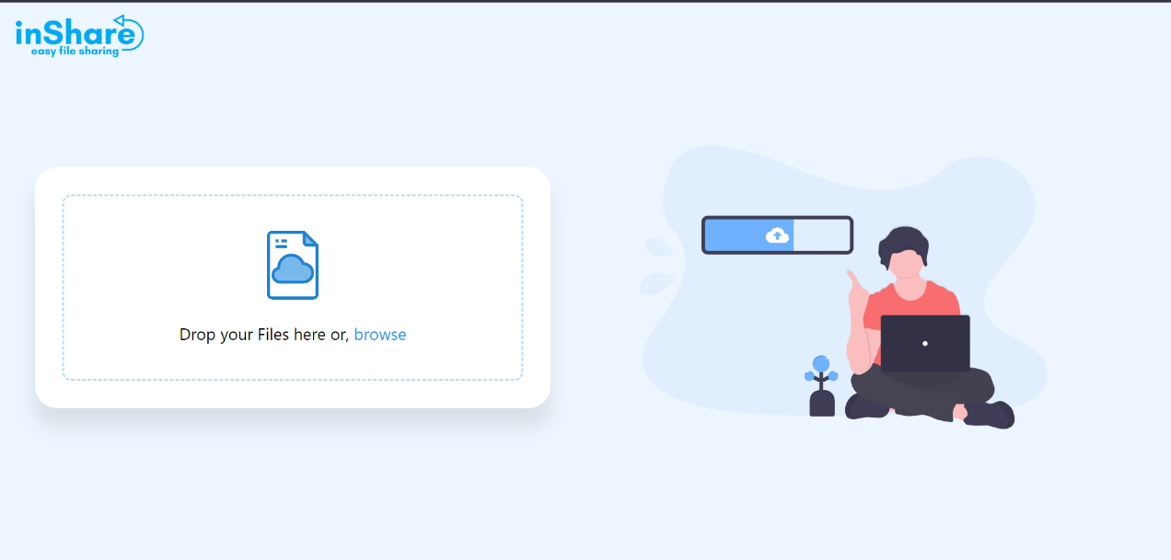

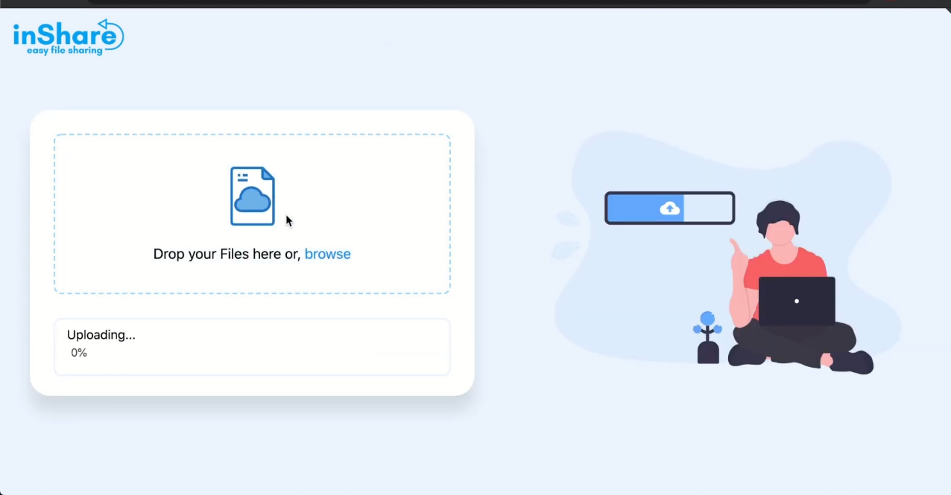

**Link Generating:**

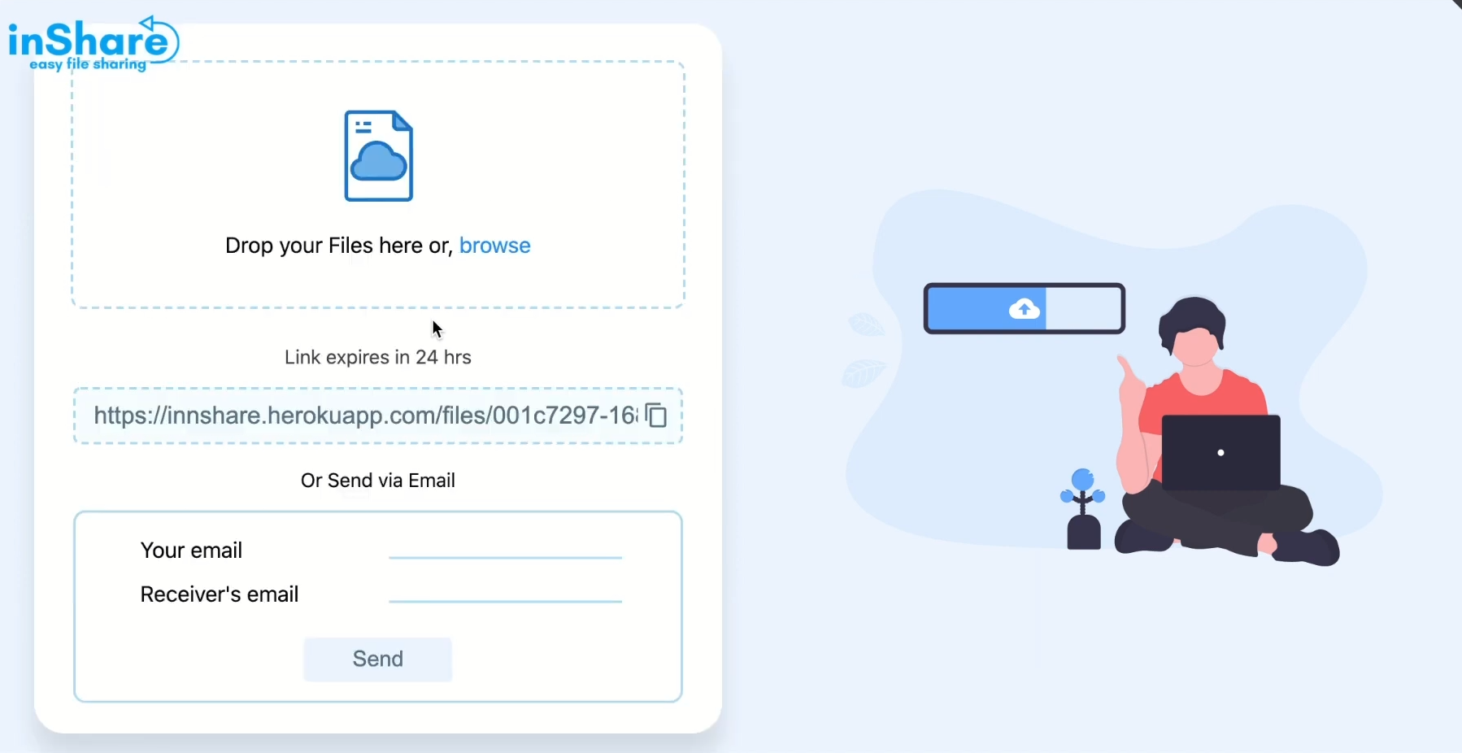

**Download through Link:**

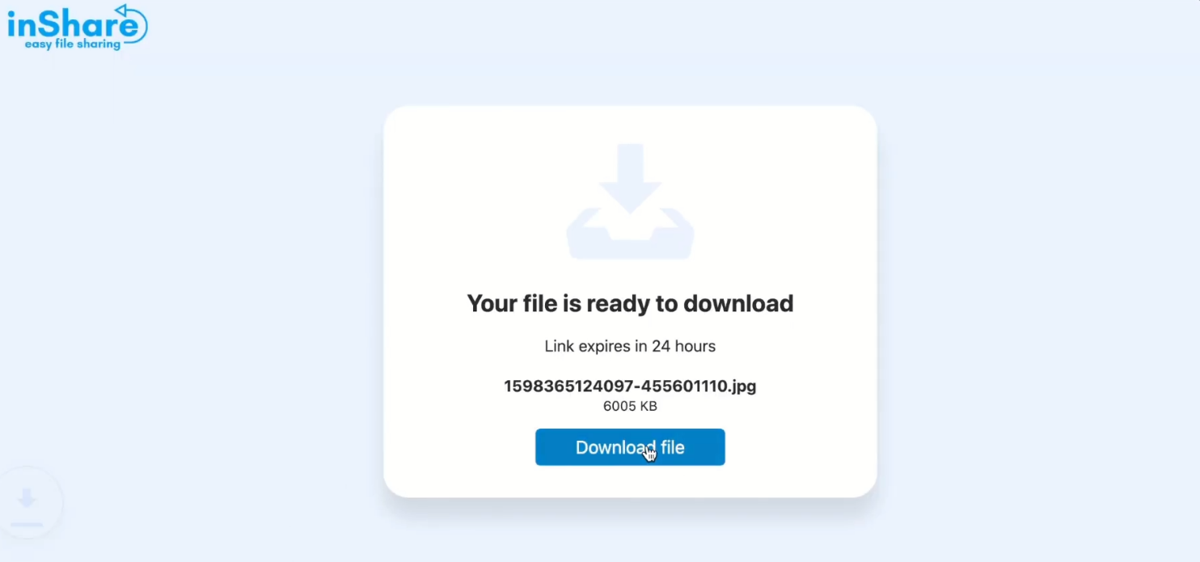

**Database**

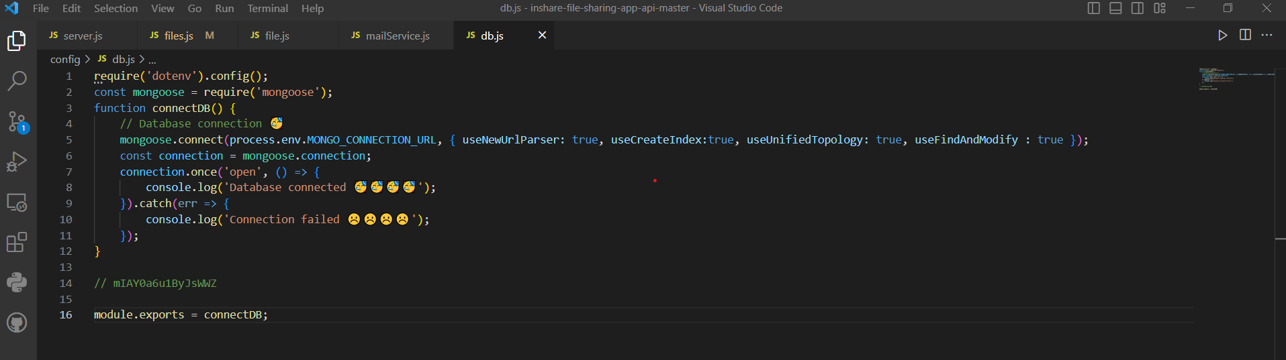

**download Page**

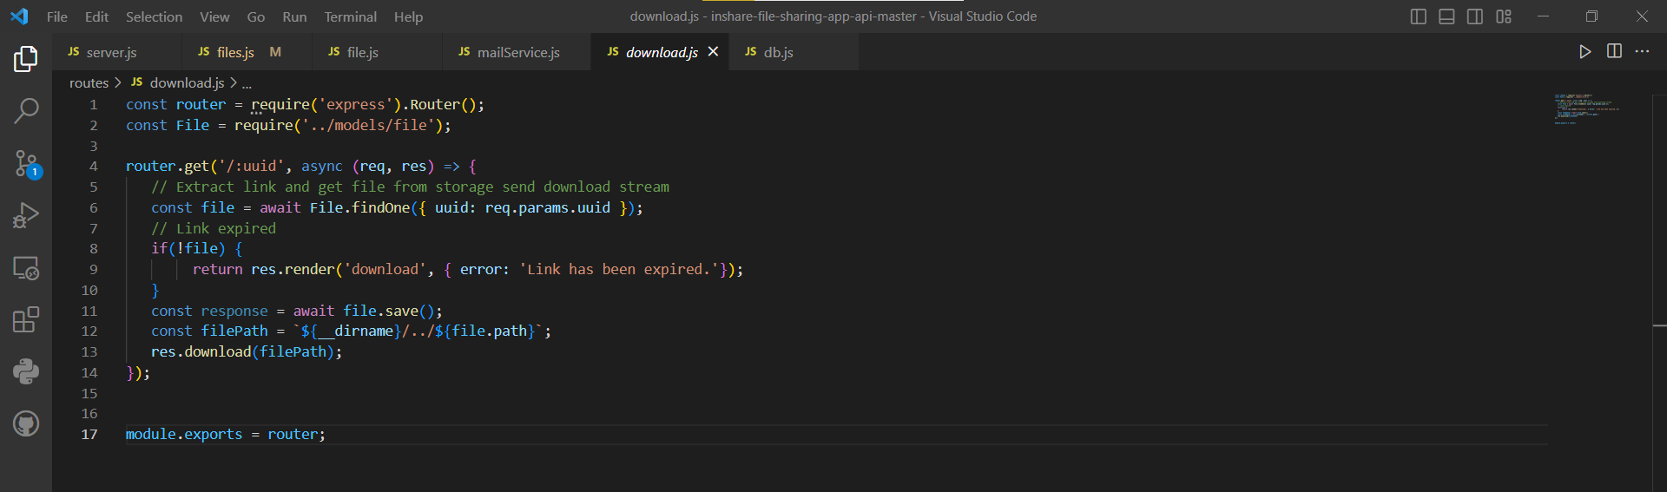

### Upload services

### 

**DownloadTest Section**

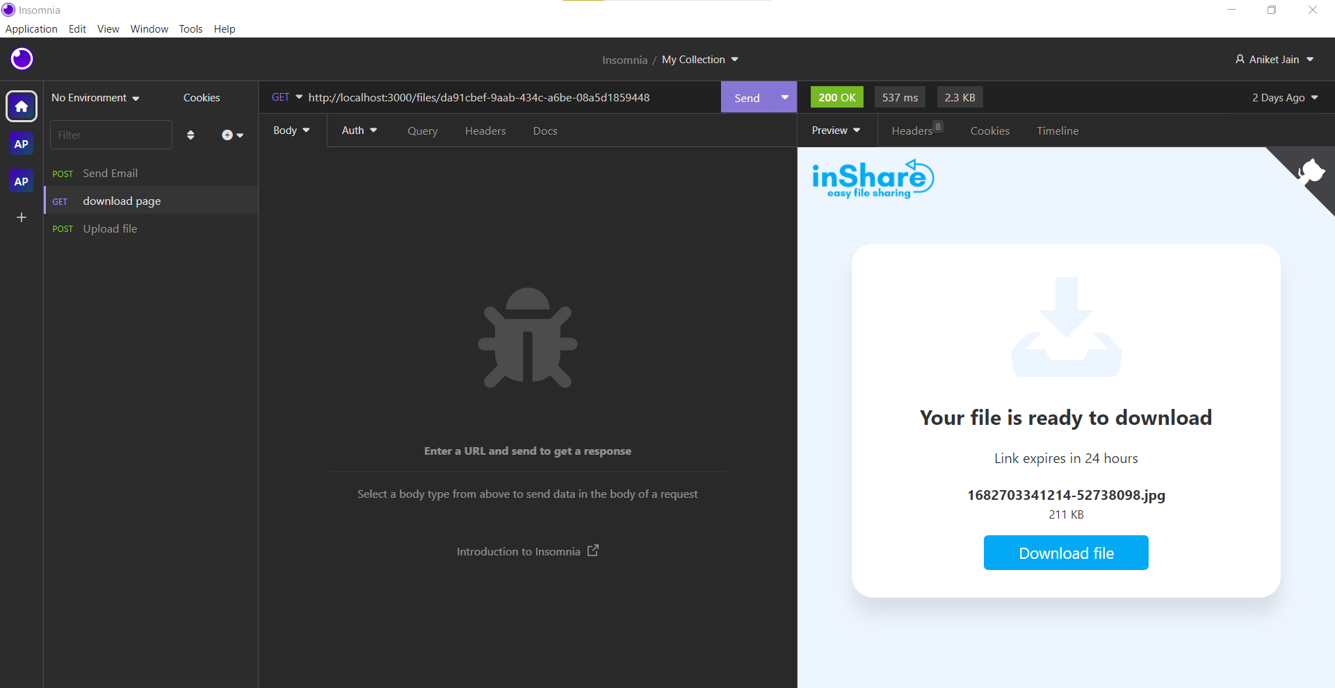

### Email Page

### 

### Packages

### 

# Chapter 4

### Software Testing

Once source code has been generated, software must be tested to uncover as many errors as possible before delivery. It is very important to work the system successfully and achieve high quality of software. Testing include designing a series of test cases that have a high likelihood of finding errors by applying software-testing techniques. System testing makes logical assumptions that if all the parts of the system are correct, the goal will be successfully achieved. The system should be checked logically. Validations and cross checks should be there. Avoid duplications of record that cause redundancy of data. In other Words, Testing is the process of evaluating a system or its component(s) with the intent to find whether it satisfies the specified requirements or not. It is executing a system in order to identify any gaps, errors, or missing requirements in contrary to the actual requirements.

The preliminary goal of implementation is to write source code and internal documentation so that conformance of the code to its specifications can be easily verified, and so that debugging, testing and modifications are eased. This goal can be achieved by making the source code as clear and straightforward as possible.

Simplicity, clarity and elegance are the hallmark of good programs, obscurity, cleverness, and complexity are indications of inadequate design and misdirected thinking. Source code clarity is enhanced by structured coding techniques, by good coding style, by, appropriate supporting documents, by good internal comments,

and by feature provided in modern programming languages. The implementation team should be provided with a well-defined set of software requirement, an architectural design specification, and a detailed design description. Each team member must understand the objectives of implementation.

#### TERMINOLOGY

Error The term error is used in two ways. It refers to the difference between the actual output of software and the correct output, in this interpretation, error is essential a measure of the difference between actual and ideal. Error is also to used to refer to human action that result in software containing a defect or fault.

Fault is a condition that causes to fail in performing its required function. A fault is a basic reason for software malfunction and is synonymous with the commonly used term Bug.

Failure is the inability of a system or component to perform a required function according to its specifications. A software failure occurs if the behavior of the software is the different from the specified behavior. Failure may be caused due to functional or performance reasons.

#### TYPES OF TESTING

1. **Unit Testing:** The term unit testing comprises the sets of tests performed by anindividual programmer prior to integration of the unit into a larger system. A

program unit is usually small enough that the programmer who developed it can test it in great detail, and certainly in greater detail than will be possible when the unit is integrated into an evolving software product. In the unit testing the programs are tested separately, independent of each other. Since the check is done at the program level, it is also called program teasing.

1. **Module Testing:** A module and encapsulates related component. So can betested without other system module.
2. **Subsystem Testing:** Subsystem testing may be independently design and implemented common problems are sub-system interface mistake in this checking we convention it. There are four categories of tests that a programmer will typicallyperform on a program unit.
3. Functional test
4. Performance test iii Stress test

iv Structure test

**Functional Test:** Functional test cases involve exercising the code with Nominal input values for which expected results are known; as well as boundary values (minimum values, maximum values and values on and just outside the functional boundaries) and special values.

**Performance Test:** Performance testing determines the amount of execution timespent in various parts of the unit, program throughput, response time, and device utilization by the program unit. A certain amount of avoid expending too much effort on fine-tuning of a program unit that contributes little to the overall

performance of the entire system. Performance testing is most productive at the subsystem and system levels.

**Stress Test:** Stress test are those designed to intentionally break the unit. A great deal can be learned about the strengths and limitations of a program by examining the manner in which a program unit breaks.

**Structure Test:** Structure tests are concerned with exercising the internal logic of a program and traversing particular execution paths. Some authors refer collectively to functional performance and stress testing as “black box” testing.

While structure testing is referred to as “white box” or “glass box” testing. The major activities in structural testing are deciding which path to exercise, deriving test date to exercise those paths, determining the test coverage criterion to be used, executing the test, and measuring the test coverage achieved when the test cases are exercised.

## CHAPTER 5

## REFERENCES

**Books:**

* JSP

Web Development with java Server pages Duane K Fields

Mark A Kob

* Core Servlets and JSP – Marty Hall
* Java

Java2 Complete Reference Sun java Documentation

* Professional Java Server Programming

J2EE 1.3 Edition

a! aprèss publication

# 

# Chapter 6

### Conclusion

We have completed our project within time limit with the coordination of our team members under the supervision of our mentor Mr. Mandeep Singh

Our project repository is available at :

# <https://github.com/trivedi-ayush/fileshare-backend>

### 

### Bibliography

[www.google.com](http://www.google.com/) [www.geeksforgeeks.org](http://www.geeksforgeeks.org/) [www.youtube.com](http://www.youtube.com/) [www.w3schools.com](http://www.w3schools.com/) [www.wikipedia.com](http://www.wikipedia.com/)